Outbound Despatch Zone Request
Segregation of Local Delivery by Zone:
New zoning logic to improve faster outbound dispatch and distribution process to forwarder for local delivery.
Requests:
(1). to display the zoning on Shipping Label.
i. SG orders - Zoning defined by postage code master,
ii. Local Forwarder (for oversea orders) - Zone input in storer.VAT
Left(HAWB,3) <> 'SIN' and Mode_domestic = 'A3'

(2). Alert in Shipping label printing module, if missing zone/Postagecode.

Changes [2010.02.23]
1. Zone Setup
a. Zone by Postage code ( For SG orders)
BEEF -> 2.Setup -> Outbound Setup
b. Zone by Carrier ( for others international orders to Carrier <> XBAX)
-> Exceed -> Storer -> VAT column

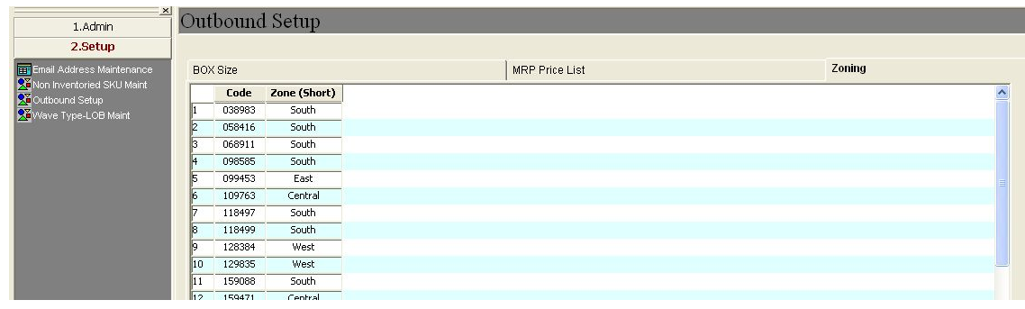

2. Print Shipping Label - add Despatch Zone on Shipping Label.
"MIssing" message will be displayed if missing Zone setup.
- see below screenshot and sample
